Practical 11: Compare AI vs Human Writing

Aim :-To compare AI-generated content with student-created content.

Objectives
• To identify difference in writing
• To understand AI limitations

Materials Required
• AI tool

Procedure1. Write paragraph manually – Compose a paragraph yourself using your own ideas, wording, and structure on the selected topic.

2. Generate same topic using AI – Use an AI tool to produce another paragraph on the same topic for comparison.

3. Create comparison table – Organize both paragraphs side-by-side in a table to compare style, clarity, tone, and content differences.

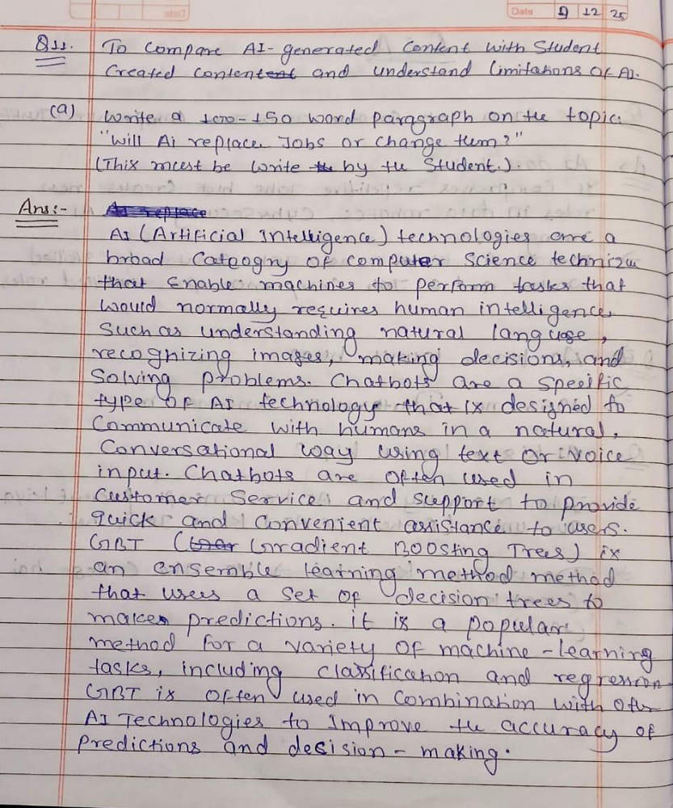

Human-Generated Paragraph:- Student Written
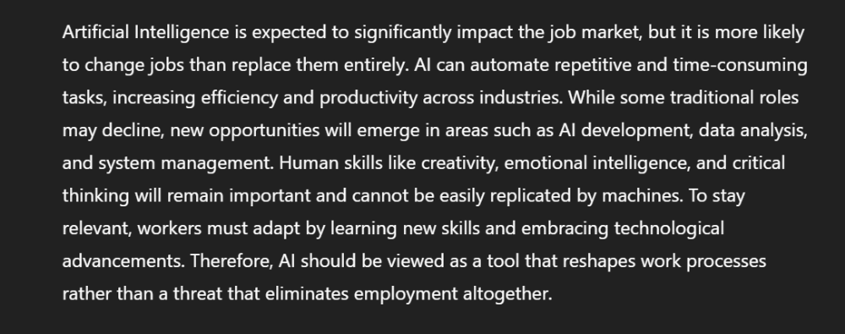

AI-Generated Paragraph ( by- ChatGPT )

